Museum Masterpieces Head Outdoors with Art Everywhere’s U.S. Debut
August 5, 2014 7:13 AM
Works by artists ranging from John Singleton Copley and Thomas Eakins to Jasper Johns and Cindy Sherman take to the streets this month with the launch of Art Everywhere U.S. Nancy Lazarus sizes up the coast-to-coast campaign that’s being billed as “the largest outdoor art show ever conceived.”
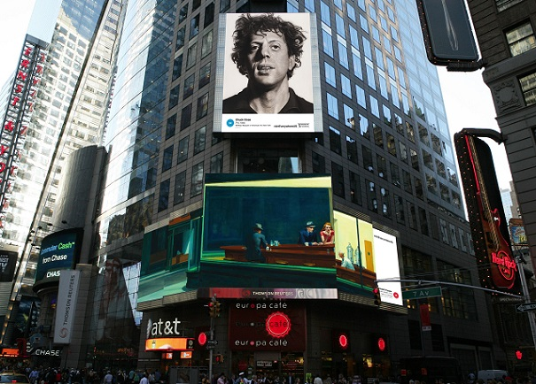
Art Everywhere U.S. Times Square rendering, featuring Chuck Close’s Phil (1969) and Edward Hopper’s Nighthawks (1942).

Can’t make it to a museum this August? Fear not. The art is coming to you thanks to Art Everywhere U.S., an extensive outdoor art show highlighting the nation’s artistic heritage. Throughout the month, images of 58 selected U.S. artworks are being projected on billboards and public spaces such as buses, trains, airports, and movie theatres across the U.S. “This is an unconventional program to promote museum experiences and to encourage the discovery of art history so it becomes part of everyday life,” said Maxwell Anderson, director of the Dallas Museum of Art, at yesterday’s kickoff event. “The goal is to continue the enthusiasm every summer.”

Inspired by the success of the 2013 Art Everywhere UK campaign, Anderson enlisted the participation of four other major U.S. museums: New York’s Whitney Museum of American Art, Washington D.C.’s National Gallery of Art, the Art Institute of Chicago, and the Los Angeles County Museum of Art (LACMA). Aside from the five partnering museums, the Outdoor Advertising Association of America (OAAA) was also instrumental in launching the initiative, which marks the organization’s largest public service campaign to date.
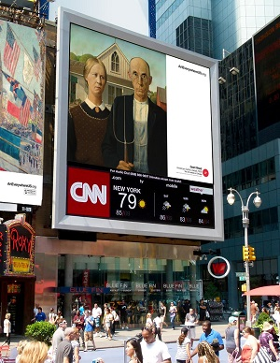
From the museum-compiled list of 100 classic and contemporary artworks, the public weighed in: casting online votes for their favorites. In late June, 58 finalists were announced, including the most popular, Edward Hopper’sNighthawks from the Art Institute of Chicago. “We brought together a stellar roster that reflects the American experience,” noted Douglas Druick, the Institute’s president and director.

The Art Everywhere U.S. website has since become an interactive art gallery, where visitors can track locations in their areas where specific masterpieces are on view. Noted Anderson, “the public can share their thoughts and take selfies” through the campaign’s integration with social media platforms including Twitter, Facebook, Pinterest and Instagram, where a contest for most creative photos is being hosted. Those who can’t tell a Ruscha from a Rosenquist can turn to Blippar. Using interactive image recognition technology, the mobile app can help identify many of the artworks in street-level displays, unlocking access to audio guides and artist information.

The other museum officials present at yesterday’s kickoff each offered their takes on what Art Everywhere U.S. may accomplish. “This will make art accessible to the public, beautify America, and hopefully drive people to museums,” said LACMA’s Michael Govan. “When people see this art, they’ll not only stop, look and ponder, but also learn about U.S. geography,” added Donna De Salvo, the Whitney’s chief curator and deputy director of programs. “We hope this is the beginning of a massive art appreciation course that will continue,” said Deborah Ziska, the National Gallery of Art’s chief of press and public information.

Richard Reed, founder of Art Everywhere UK, has set his sights even bigger: he’d like it to become an international art movement for every country. In the meantime, Americans and visitors from overseas will have unexpected encounters with artworks, like Gilbert Stuart’s George Washington gazing from Times Square, Mary Cassatt’s Boating Party rowing into Reno and Childe Hassam’s Allies Day floating over Fifth Avenue.

Pictured inset, at right: Art Everywhere U.S. rendering featuring Childe Hassam’s Allies Day, May 1917 (1917) and Grant Wood’s American Gothic (1930).

Nancy Lazarus is a frequent contributor to UnBeige.

